Go to Balloon Live website, and select software and support.

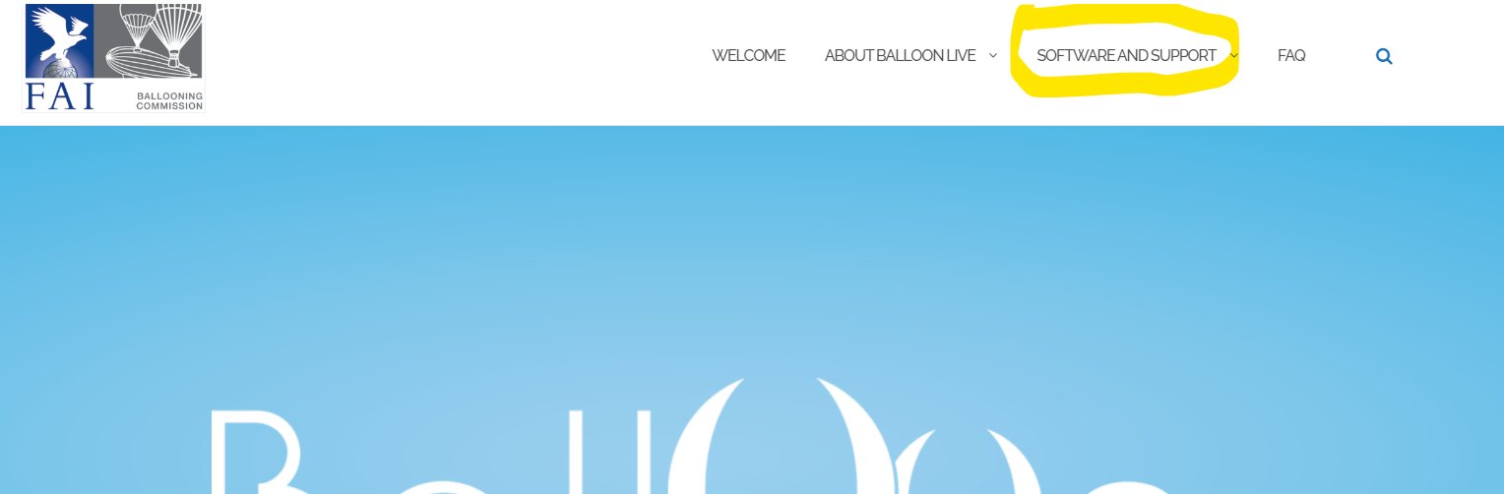
Select Downloads
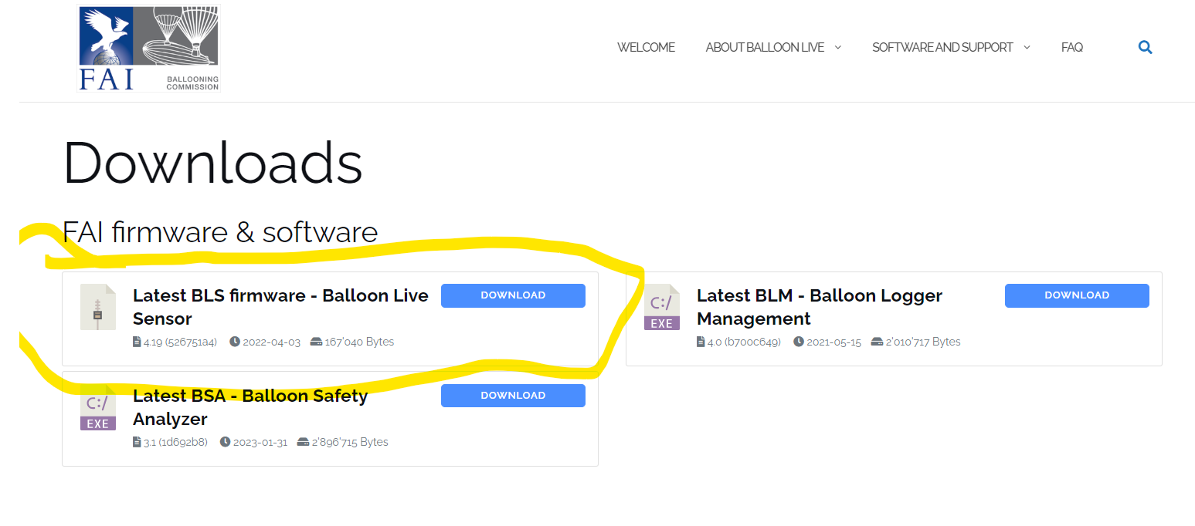
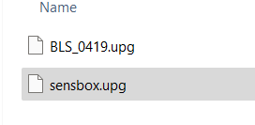

Rename the downloaded file to sensbox.upg

Connect the BLS to the computer and then switch it on.
Open the folder for the BLS and go into the “system” folder
Delete any file in this folder that has .upg
Paste the new sensbox file into this folder.
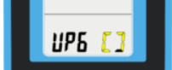
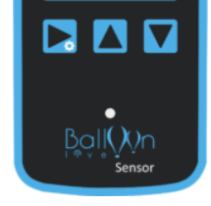
Disconnect the BLS and switch off.
Hold the left button down and then switch on this will show

The sensor will switch off.
When you switch back on it will be updated.

